**WEB PHISHING DETECTI0N**

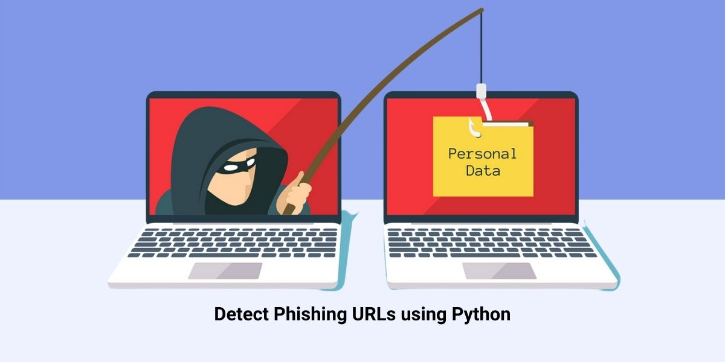*EMPATHY MAP*

*TEAM DETAILS*

*TEAM NUMBER : PNT2022TMID34399*

*COLLEGE NAME : CAPE INSTITUTE OF TECHNOLOGY*

*DEPARTMENT : INFORMATION TECHNOLOGY*

TEAM MEMBERS



|  |  |
| --- | --- |
| TEAM MEMBER POSITION | MEMBER NAME |
| TEAM LEADER | A.ISWARYA |
| TEAM MEMBER 1 | T.PARVATHY |
| TEAM MEMBER 2 | T.SALINI |
| TEAM MEMBER 3 | A.SAHAYA ABISHA |

EMPATHY MAP

|  |  |
| --- | --- |
| DATE |  |
| PROJECT NAME | WEB PHISHING DETECTION |

